1. CMPE 240 Experiment 4 Preliminary Work
   1. Truth Table:

|  |  |  |  |  |
| --- | --- | --- | --- | --- |
| **#** | **CLK** | **X** | **Y** | **Z** |
| **0** | 0 | 0 | 0 | * ? |
| **1** | 1 | 0 | 0 | 0000 |
| **2** | 0 | 0 | 1 | * ? |
| **3** | 1 | 0 | 1 | 0011 |
| **4** | 0 | 1 | 0 | * ? |
| **5** | 1 | 1 | 0 | 0110 |
| **6** | 0 | 1 | 1 | * ? |
| **7** | 1 | 1 | 1 | 1001 |

* 1. List of components used in the design:

1. D-Flip Flop (2) -> 74HC74 (1)

2. AND (2) -> 74LS11 (1)

3. NAND (4) -> 74HC132 (1)

…

* 1. 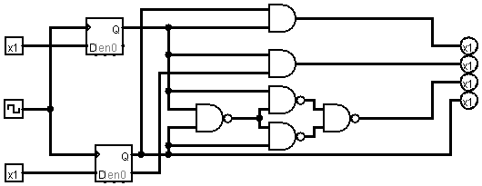Circuit: